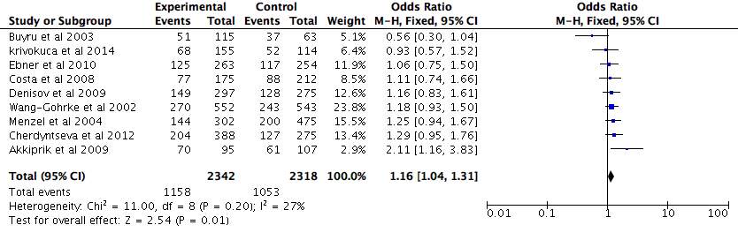Figure 3. Forest plots of the relationship between Arg78Pro polymorphism of the P53 and breast cancer in the dominant model. The black diamond denotes the pooled OR; blue squares indicate the OR in each study with square sizes inversely proportional to the standard error of the OR; and horizontal lines represent the 95% CI.

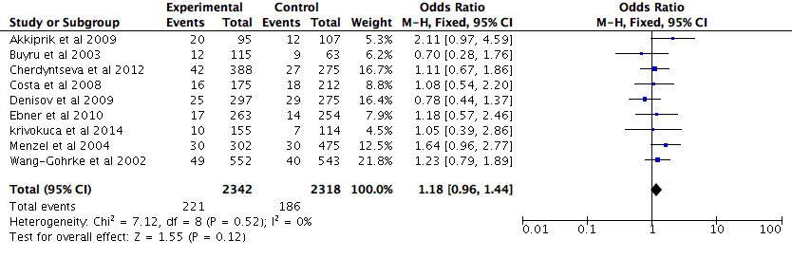Figure 4. Forest plots of the relationship between Arg78Pro polymorphism of the P53 and breast cancer in the recessive model. The black diamond denotes the pooled OR; blue squares indicate the OR in each study with square sizes inversely proportional to the standard error of the OR; and horizontal lines represent the 95% CI.

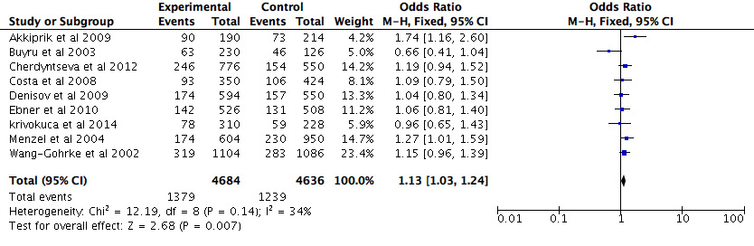Figure 5. Forest plots of the relationship between Arg78Pro polymorphism of the P53 and breast cancer in additive model. The black diamond denotes the pooled OR; blue squares indicate the OR in each study with square sizes inversely proportional to the standard error of the OR; and horizontal lines represent the 95% CI.

